President and Chair’s 2024 AGM speech

1,441 words

As I stand before you today, I am filled with excitement and optimism about the opportunities ahead of us as the State’s largest Club.

As you have just seen in the opening video and as I reflect on this past year, we were proud to unveil our refreshed vision and values that will guide us towards a future full of promise and possibility for all our members and more broadly, Queenslanders.

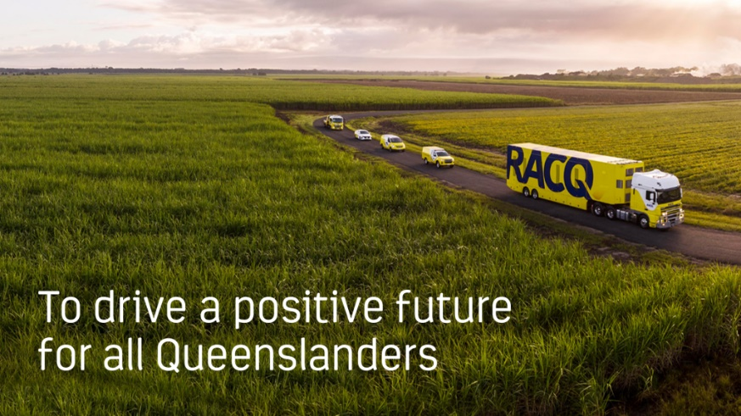

Our purpose, “To drive a positive future for all Queenslanders”, inspires our vision to be the trusted partner for our members, providing solutions that help them move and live safely, securely, and sustainably.

Together, they chart a course for a future where our Club remains meaningful and relevant, helping Queenslanders in their transition to renewable energy.

Supporting our purpose are our values of Show Care, Own It, Embrace Learning, and Deliver Excellence which serve as a compass, setting the standards and behaviours that we hold ourselves and each other accountable to.

We are committed to developing good people and empowering them with a positive workplace culture that enables them to do good for our members, our community and each other, every single day.

The importance of our purpose and vision has never been clearer as cost-of-living challenges continue to impact our members through rising insurance premiums, high fuel and energy prices, and interest rates.

We remain steadfast in our commitment to advocate on behalf of our members to make our roads safer and expand our Member Benefits program to help make everyday life more affordable.

Performance overview

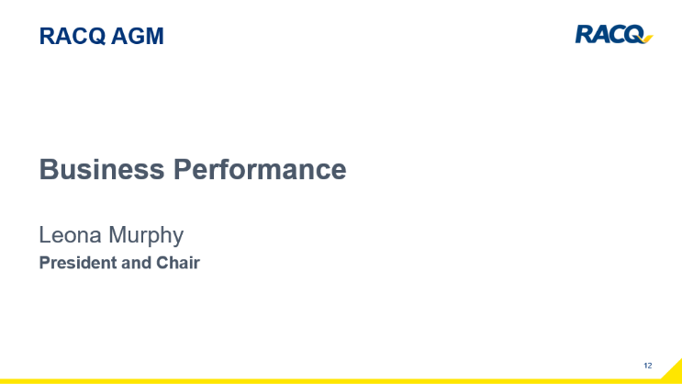

FY24 has been a year of solid progress across the business and this is reflected in our results, where your Club delivered a surplus of 73.3 million dollars after tax.

This achievement was driven by improved performances across all our business lines.

The profit allowed us to provide 8.4 million dollars to communities and charities across the State and make the necessary investments to drive our 2032 strategy.

RACQ continues to be financially strong and well-capitalised, enabling us to deliver on our commitments. This includes helping our members get back on their feet when damage or theft occurs, and when natural disasters strike as they did across a large part of the State last summer.

Our Managing Director and Group CEO David Carter will speak more to the financial results in his address shortly.

Risk Transformation Program

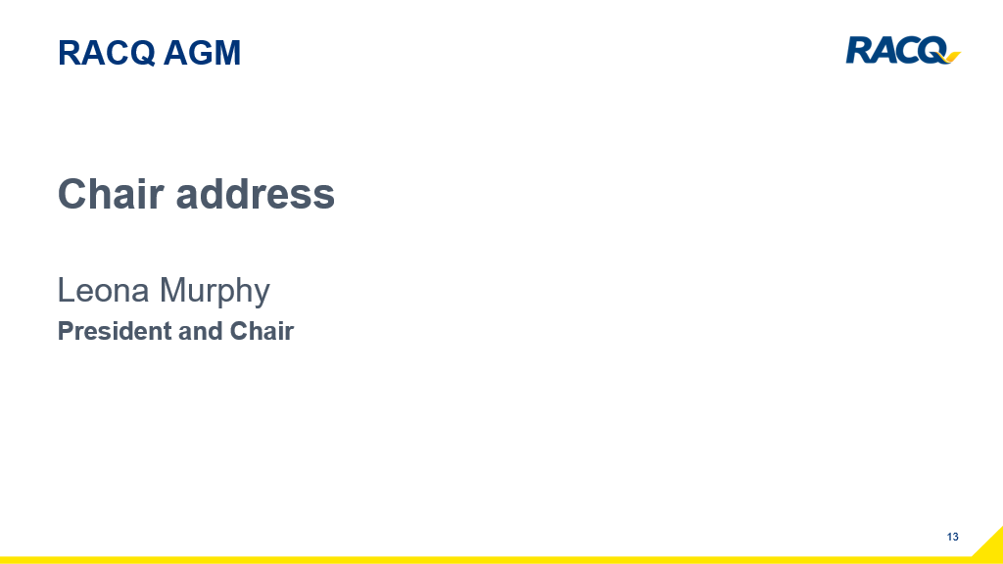

FY24 underscored our journey towards setting a new standard of performance as we progressed our multi-year Risk Transformation Program.

The board is deeply committed to this crucial work, aimed at enhancing our risk management, governance, systems, and culture to improve outcomes for our members and our business alike.

Throughout the year, the program introduced various initiatives to foster a positive risk culture and ensure a clear understanding of responsibilities and accountabilities right across the organisation.

These efforts have strengthened RACQ’s risk governance frameworks and processes, leading to more proactive management of risk.

Cyber Security

When talking about risks, cyber security continues to remain top of mind for many of our members.

In response to the growing cyber threats across the country, RACQ held several face-to-face education awareness sessions aimed at helping members become more risk aware.

This important information was also made available to our regional members through our retail stores.

In addition, our ‘Stop, Think, Protect’ messaging aimed at helping our members identify and prevent scams reached more than 60 thousand people through quarterly emails and more than 200 thousand through RACQ’s social media channels.

At a business level, we continue to improve and embed our cyber risk prevention, monitoring, and response controls into our risk framework to guard against threats and maintain a resilient technology environment.

Towards 2032

While we are managing risks, we are also looking at new opportunities to solve the emerging needs of our members.

Both the energy and mobility sectors are undergoing significant transitions, characterised by the increased adoption of renewable energy and the decarbonisation of transport.

We believe RACQ has an important role to play in this transition.

As we advance our 2032 strategy, we are creating a simpler and more efficient organisation that enables us to participate in new and exciting markets.

This allows us to better support our members, making it easier and more affordable for them to transition to renewable energy solutions.

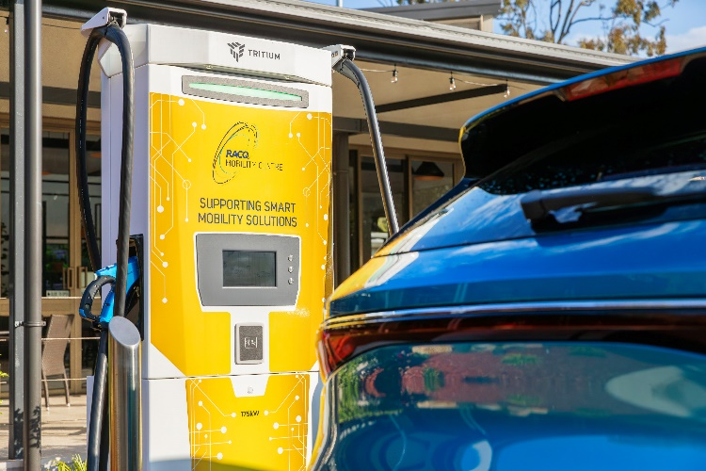

With strong foundations, the Club is transforming, ready to expand on its core services to include new auto services to support both internal combustion engines as well as electric vehicles. We are also investing in public and home EV charging.

We stand by our members, recognising that their journey to a low-carbon future will be varied and unique. Our commitment is to support our members wherever they are and whenever they are ready.

Our commitment to members extends to supporting our communities, helping them to build resilience in the face of climate change and the increasing severity and frequency of natural disasters.

During the year, the RACQ Foundation continued to deliver vital on-the-ground support through four Community Assistance projects.

I personally had the privilege of being part of this work in Blackall, where we supported drought and flood-impacted stations; in Gympie, we planted three thousand trees and shrubs on the banks of the Mary River.

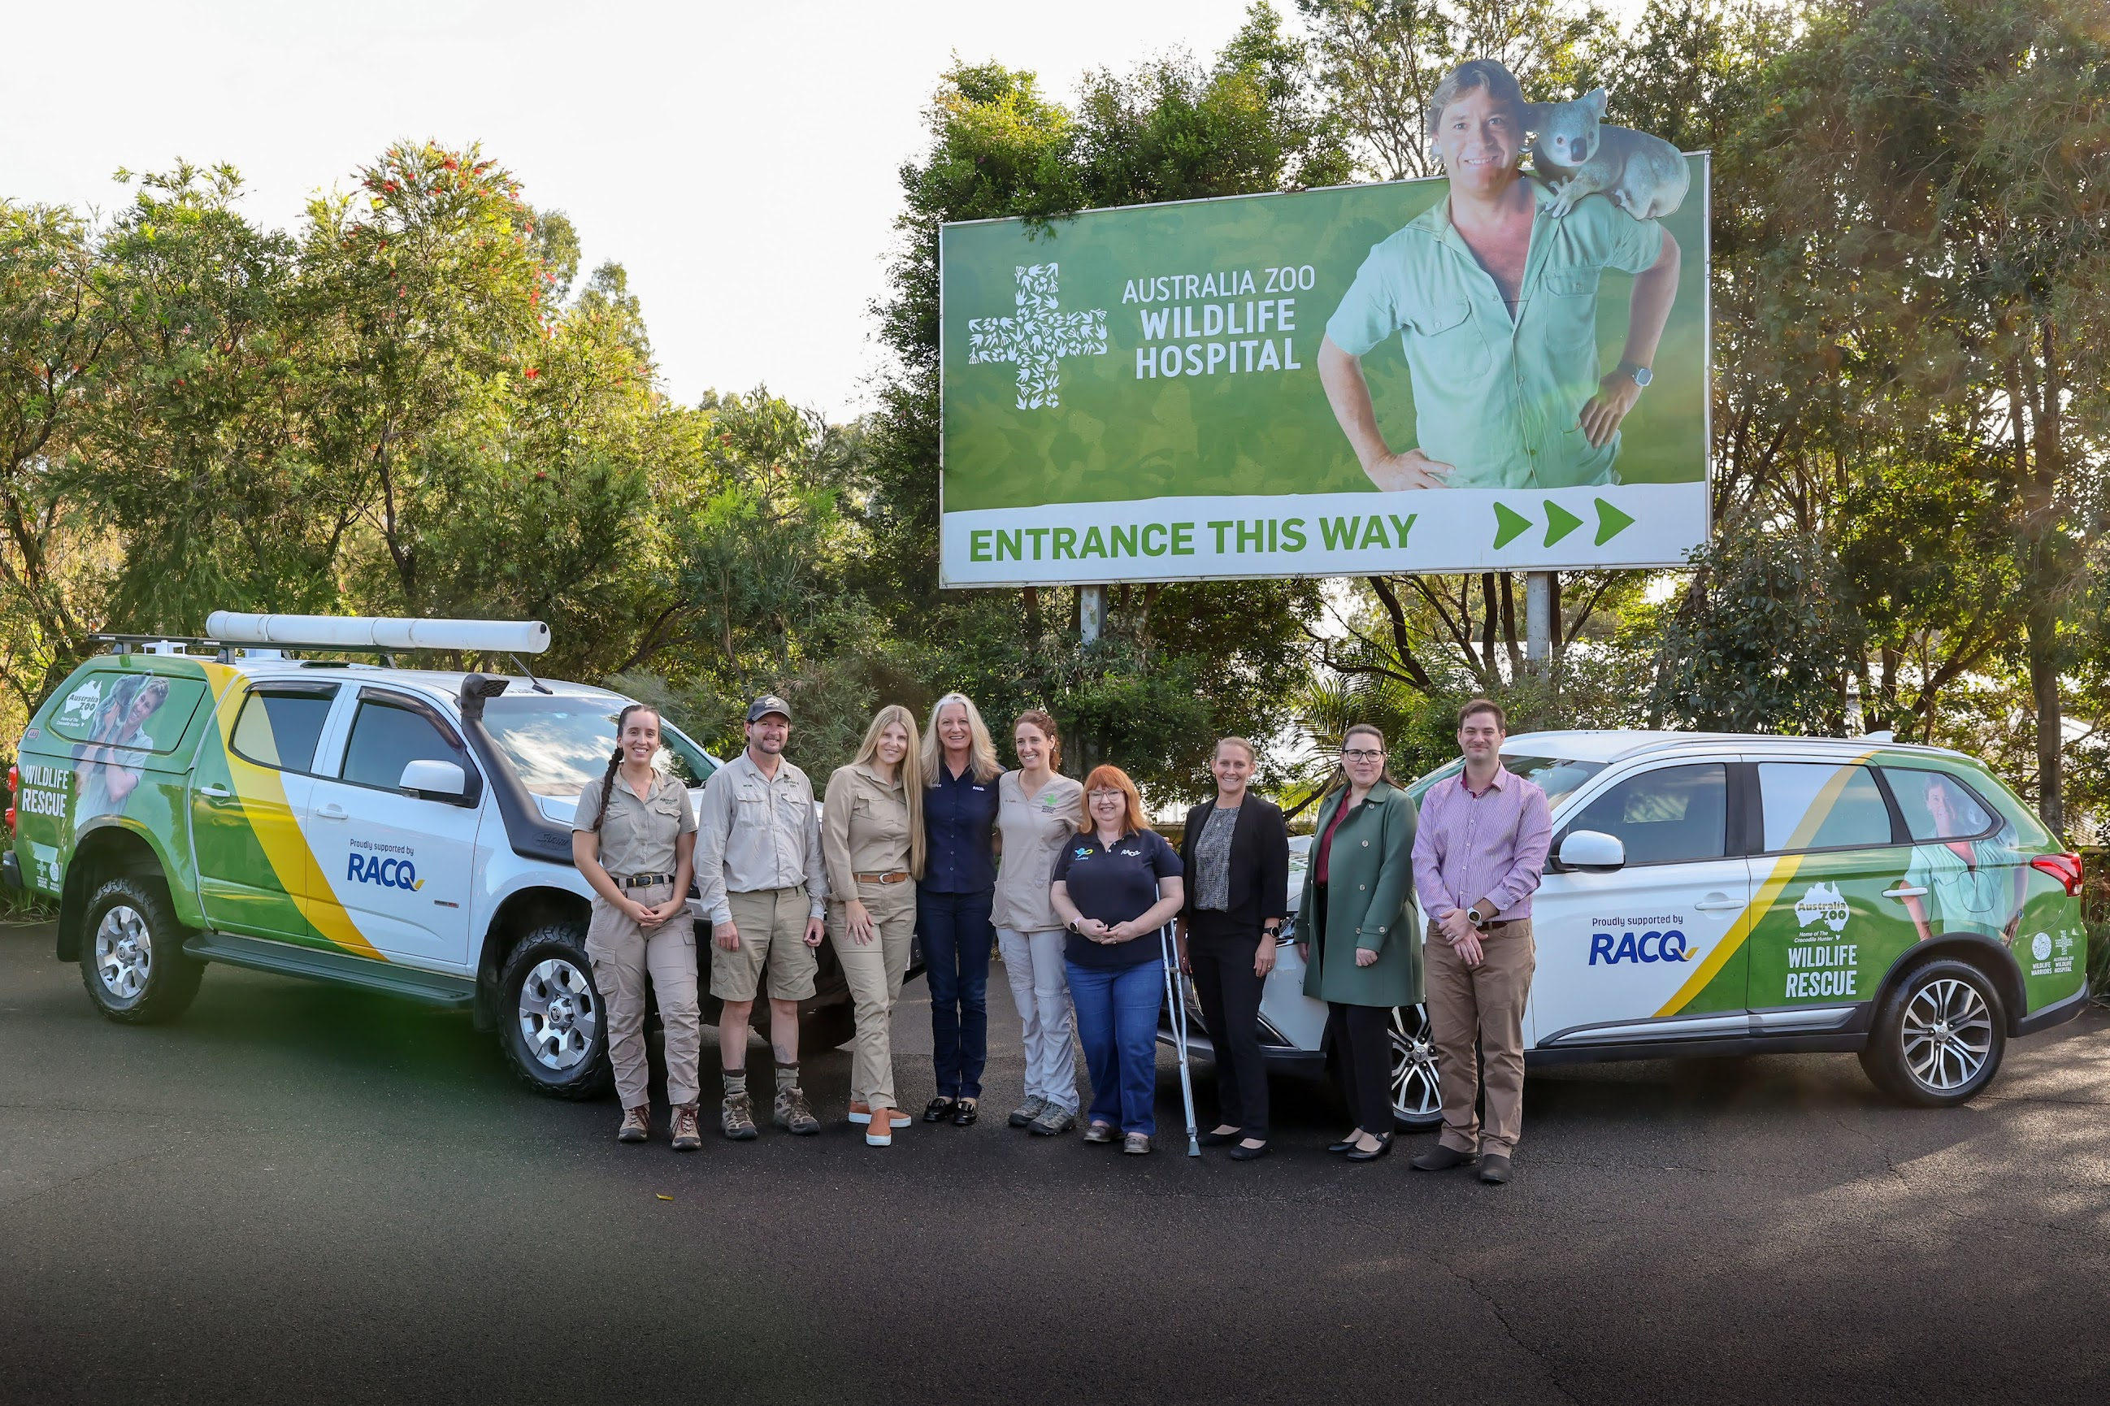
At Australia Zoo, our team of volunteers cleared debris from a nearby eucalypt plantation, which was impacted by the 2022 floods, and helped plant more than one thousand new seedlings.

These new trees will provide a much-needed food source for the koalas at the hospital and at the zoo in future years.

Celebrating an incredible 10 years of partnership with Wildlife Warriors, we also provided two new vehicles for use as animal ambulances.

The board also joined Foundation volunteers in the First Nations community of Cherbourg to assist in several projects to support the local community.

From helping the local Youth Action Group build a new nursery to generate income, to upgrading the Cherbourg Hornets Rugby League Club facilities, to digitise of the community’s history which is held at the Ration Shed Museum.

The expansion of our Community Grants program to include a resilience category also marks a significant step in our support, helping to build more climate resilient communities.

Our commitment to driving positive change through road safety advocacy and education programs remains a priority.

During the year, more than 65 thousand people participated in our Road Safety Education Programs across the State.

We launched our Blooms for Blokes campaign, a powerful road safety initiative, highlighting the high number of male deaths on our roads over the past five years.

The road toll continues to climb and it’s shocking in an age when cars have never been safer to drive, and when road safety should be front of mind for all road users.

David will provide further detail on our advocacy word in road safety.

Board update

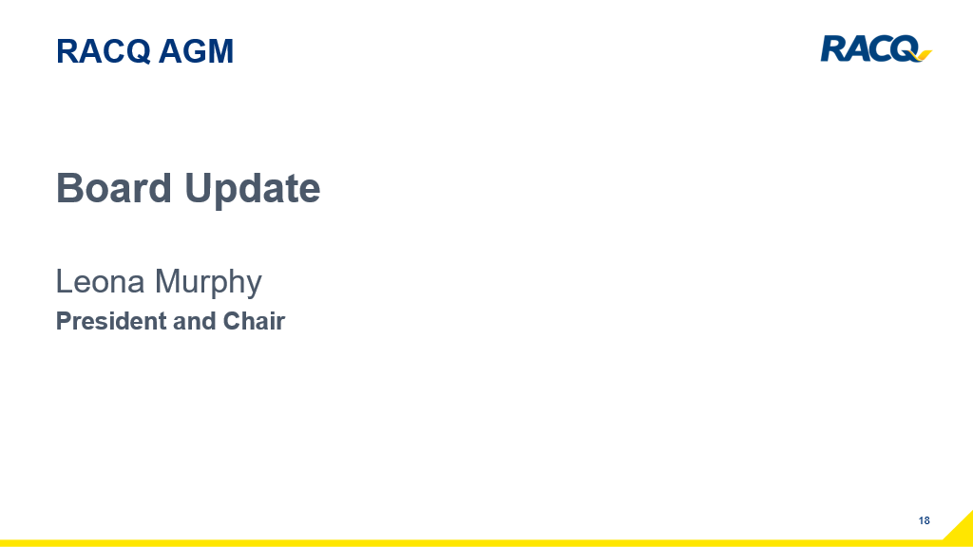

Turning to board matters, there were several key governance changes during the year, including David’s appointment to a director on the board to reflect his leadership and value that he brings to the boardroom.

Following changes to the constitution approved at the 2023 AGM, directors’ fees for all RACQ companies are now met through a single fee pool approved by members and this has resulted in efficiencies and a reduction in costs.

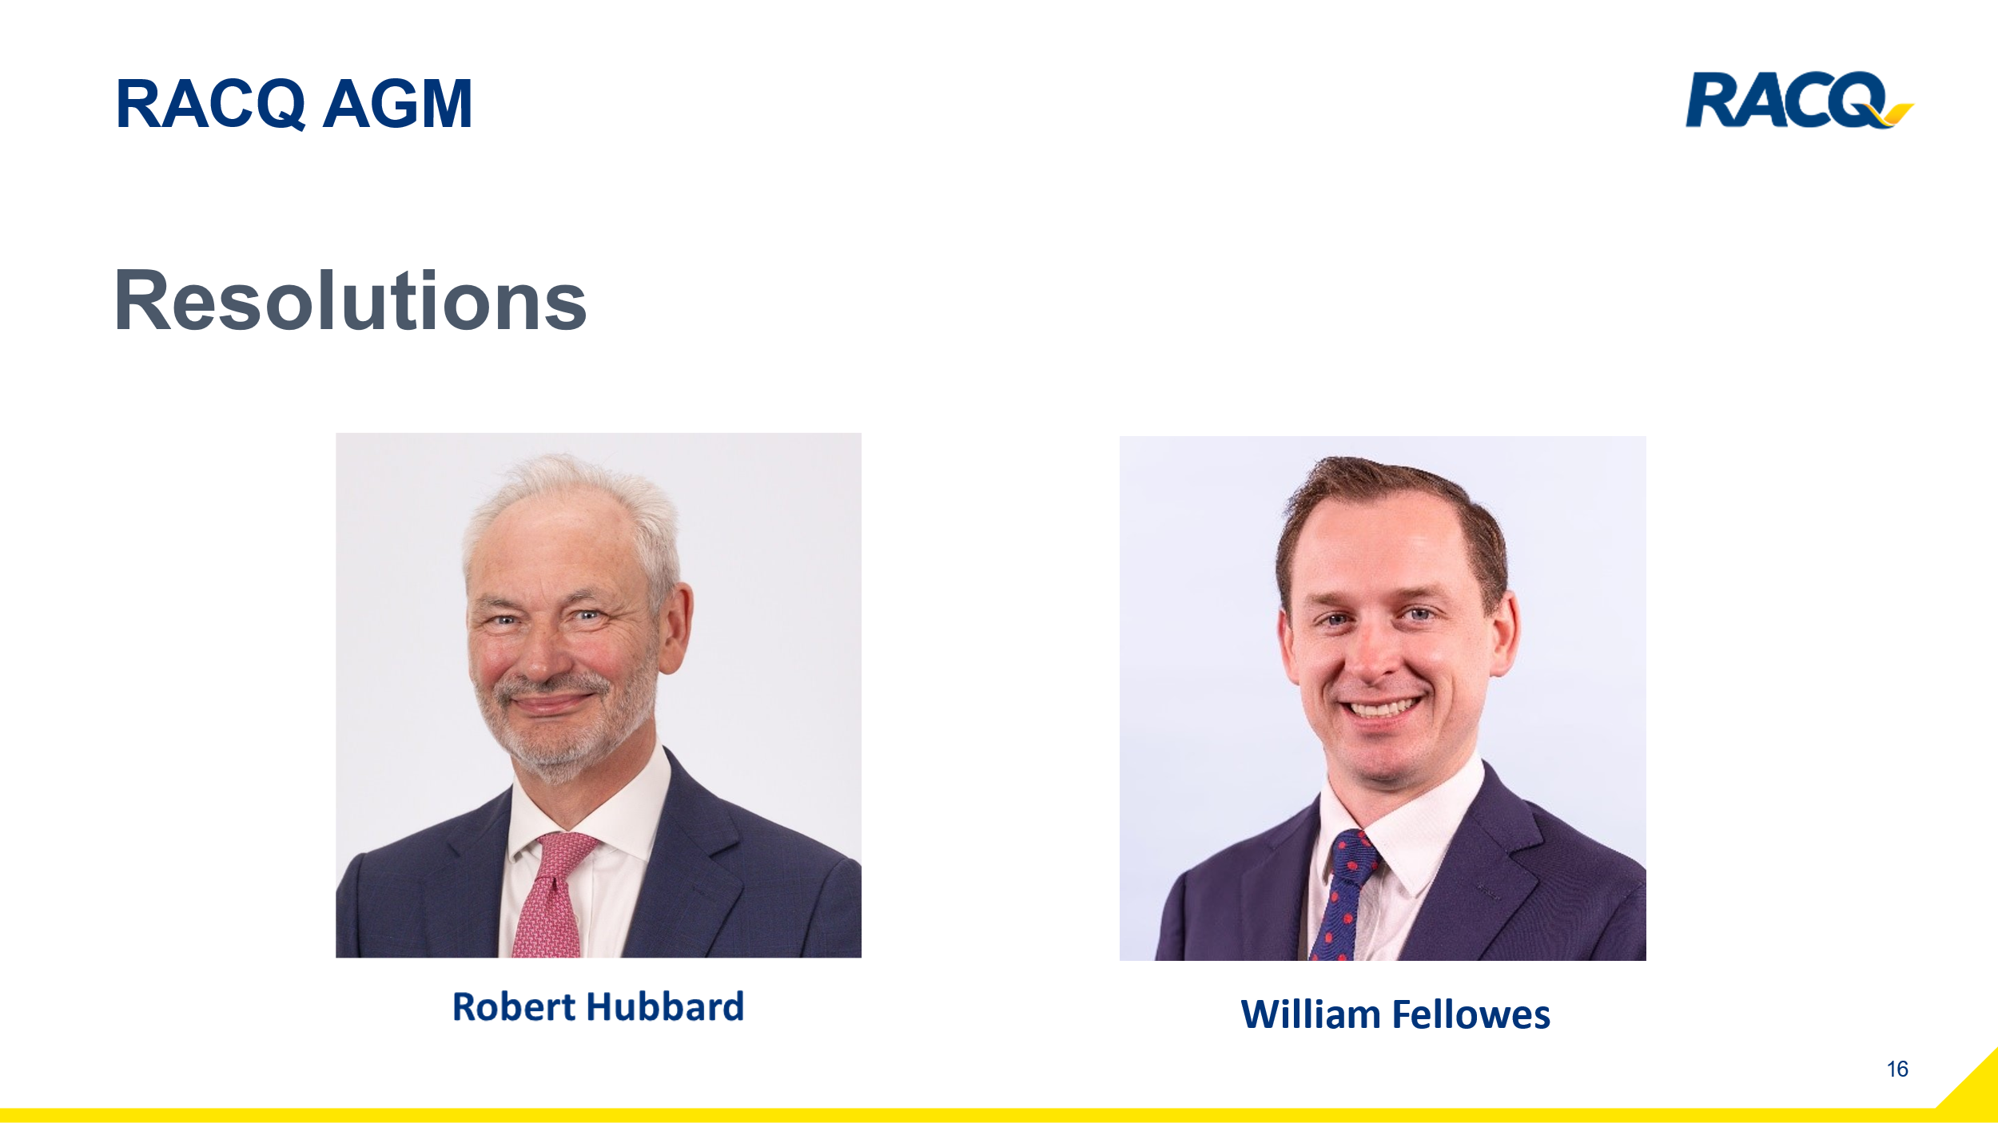

In terms of today’s resolutions – the two sitting directors facing re-election are Rob Hubbard and Will Fellows.

Both are experienced RACQ directors who bring a wealth of knowledge and specialist skills to their roles. The board unanimously recommends you vote in favour of their re-election.

I would like to thank my fellow board members for their dedication over the past year. Their skills, experience, hard work, and commitment have been highly valued.

In Closing

In closing, FY24 has been a year of significant change, simplification and getting the foundations in place for our future.

None of the achievements during the year would have been possible without the hard work of RACQ’s people.

I want to acknowledge David’s leadership and the entire executive team, as well as the dedicated staff and contractor network who are there for our members in their moments of need.

I would also like to extend my heartfelt thanks to our members for your ongoing loyalty and support.

You help us make a difference in building more resilient communities.

As we move into FY25 and the Club’s momentous 120th anniversary, we remain focused on delivering our 2032 strategy and driving a positive future for all Queenslanders.

Before we move to the formal business of today’s meeting, I would like to invite David to say a few words.

Ends

